**LAB 5**

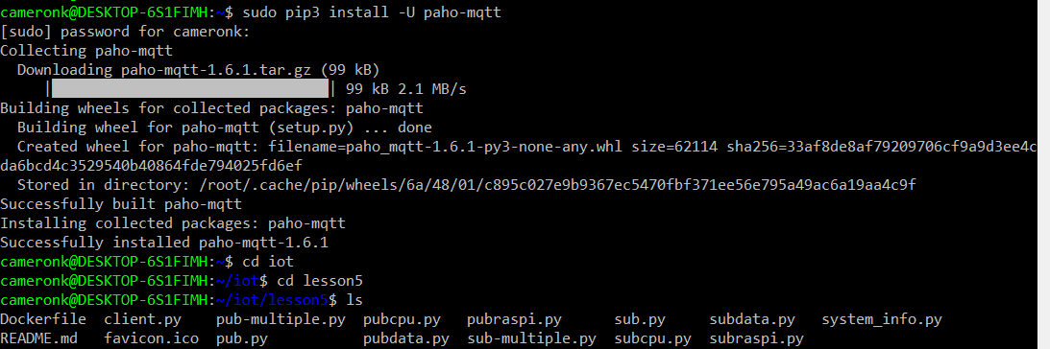

Installation of Paho-MQTT

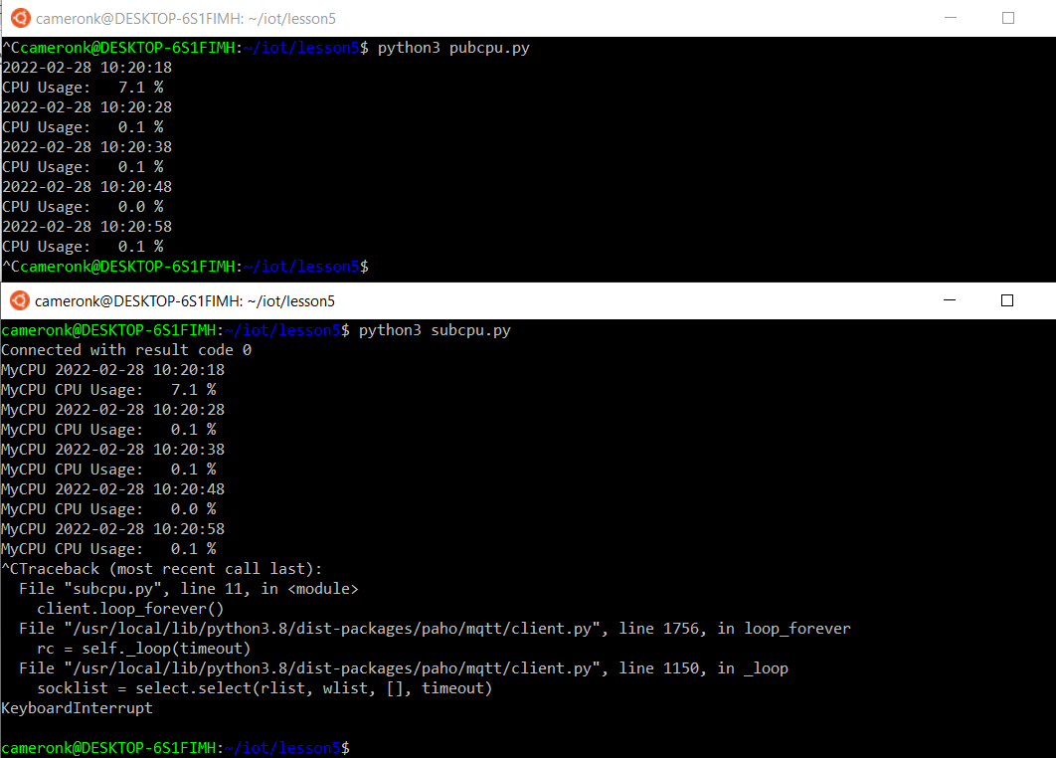

Two terminals communicating, with one publishing cpu information and one is subscribing to that information.